Game Play Summary – 3D Lattice Voyage – Spr2012 NSF DUE #0837162 Accessibility of Materials Laboratory Experience for Engineering Undergraduates, K. Morsi, M. Siprut, M. Bresciani, K. Stewart
Report from Dr. K. Stewart on game development progress. The three labs promised in our original grant have been created and shared with students of Dr. Morsi at SDSU. This section provides a summary of the newest Lab – the Virtual Field Trip into the Lattice. Gameplay begins with our splash screen, recognizing the support from the National Science Foundation and identifying the lab as the Lattice Voyage. Our group logo, designed by graphic artist under the direction of Dr. M. Siprut, presented.
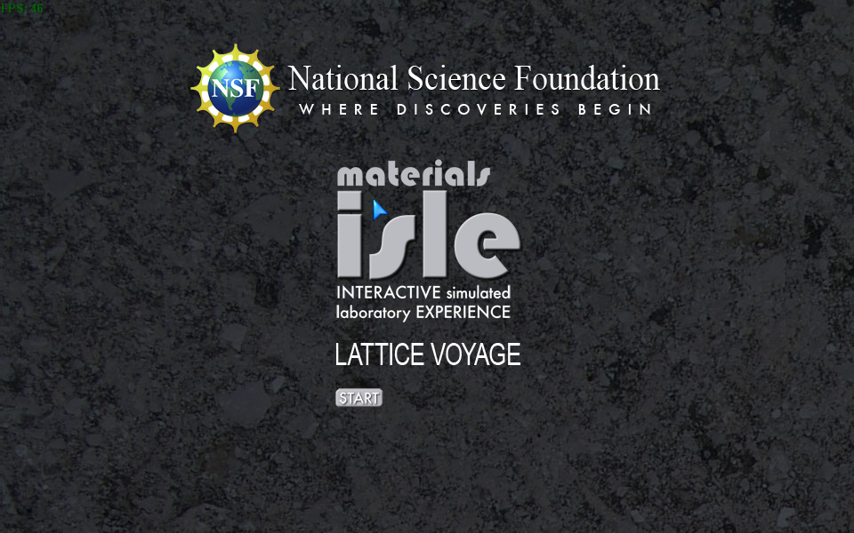
The game user then proceeds through several instructional screens providing specific direction for the lab.
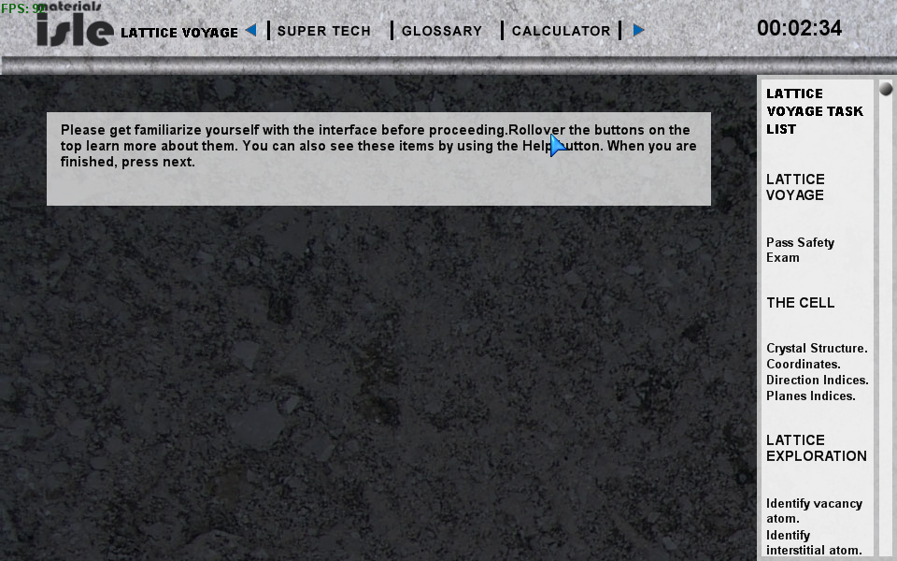
The Task List on the Right Hand Side (RHS) of the screen provides guidance for this lab introduces the user to game goals.
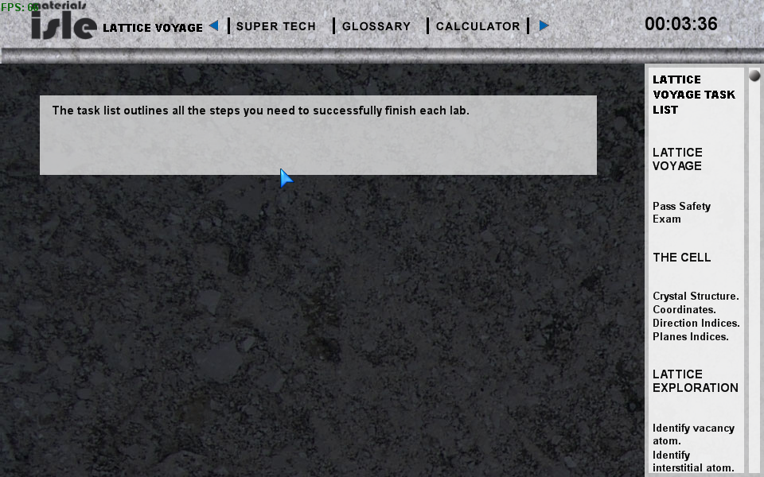
The game development system using XNA 3.1 does not easily allow a user to repeat a step in the game. Therefore, we advise the user to examine the information carefully, before proceeding to the next step by selecting the Blue right arrow in the upper band of the title bar.
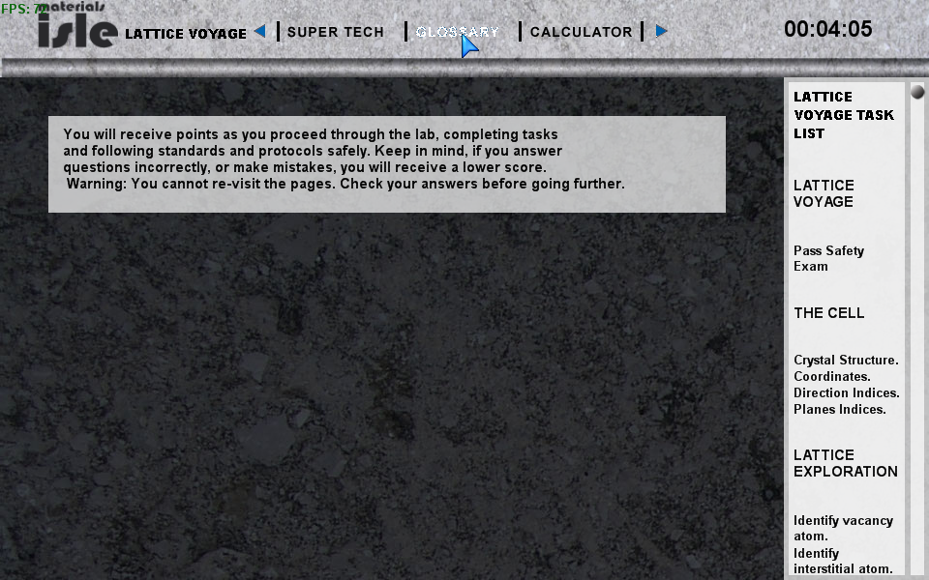
The goals of this particular lab is then described:
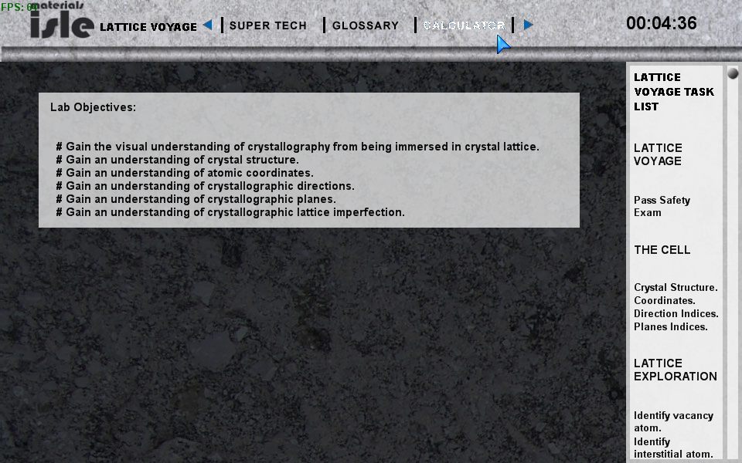
The student is presented with a Safety Quiz before being allowed to enter the lab. This is key to a real life laboratory experience where safety is important for the student, the fellow students, the equipment in the lab and more.
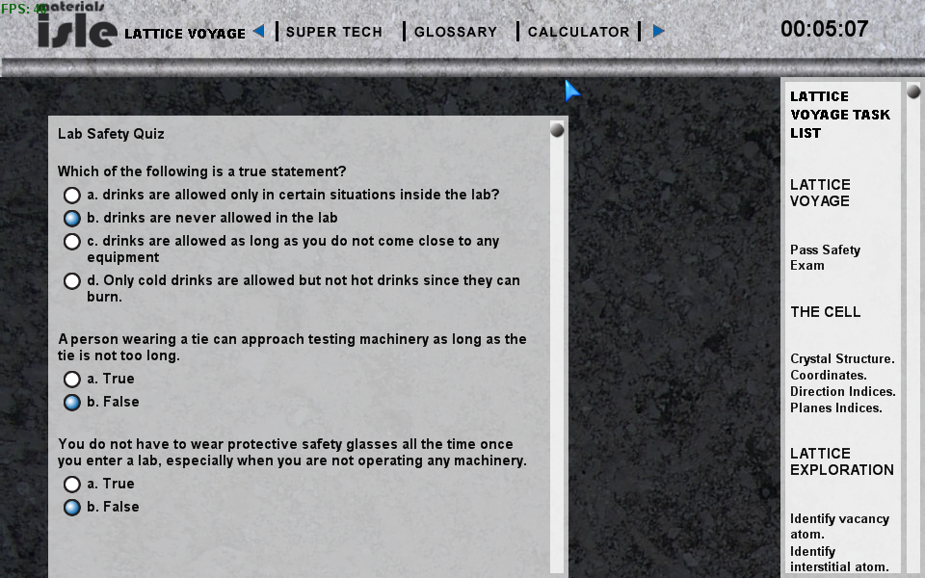
The student scrolls down to complete all questions and after correctly answering, the student may enter the lab. The game software collects information on the student (through the login at the start) and saves the number of attempts for each question to find the correct answer in an external, online database residing in another campus system, rohan.sdsu.edu. This is a My SQL database.
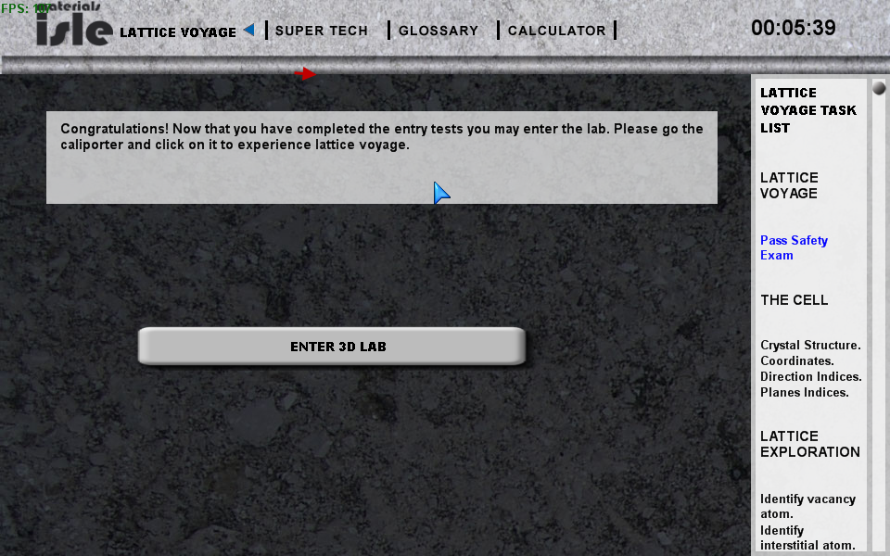
After successfully completion of the safety, the student enters the 3D lab, initially facing the Teleporter station.
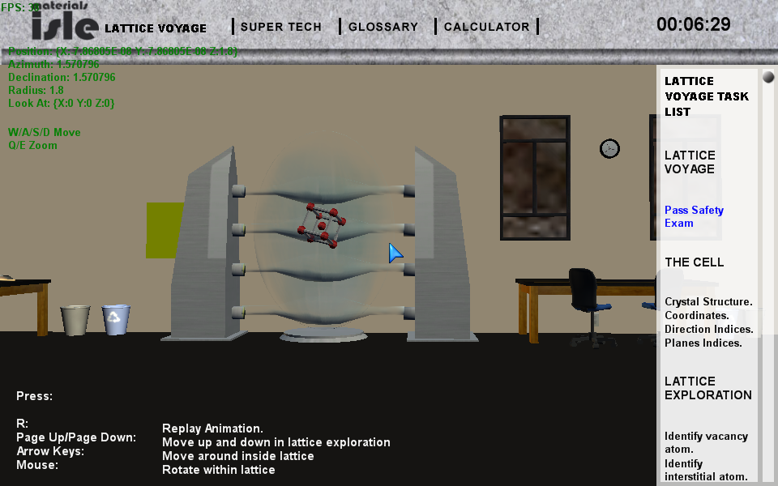
But the student is still free to look around the lab to inspect the other facilities available using the mouse for navitation. Since the software in modularized for each lab, the student will not be able to activite other labs now, but can take a look.
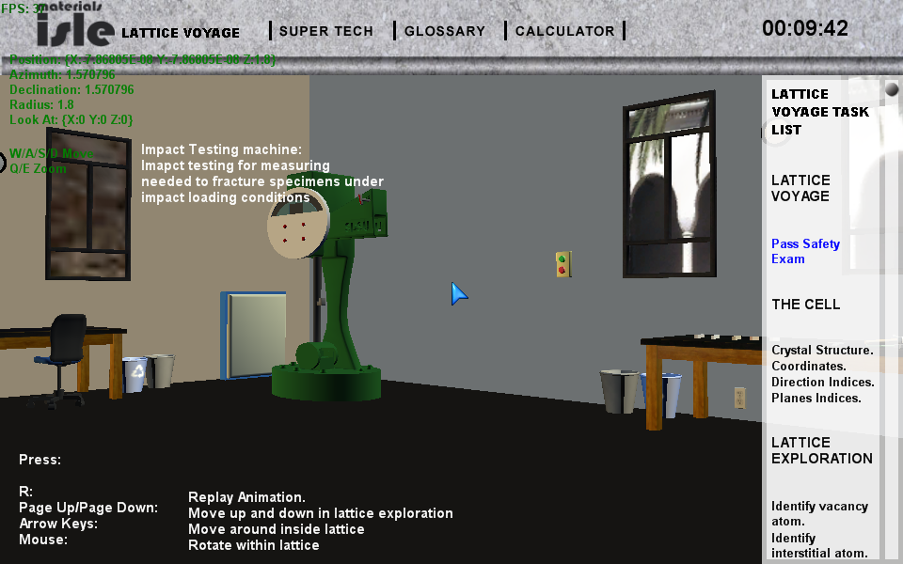
Above we have the Impact Testing device, along with the sample tables that students use in that lab.
Below is the representation of the Tensile Testing device.
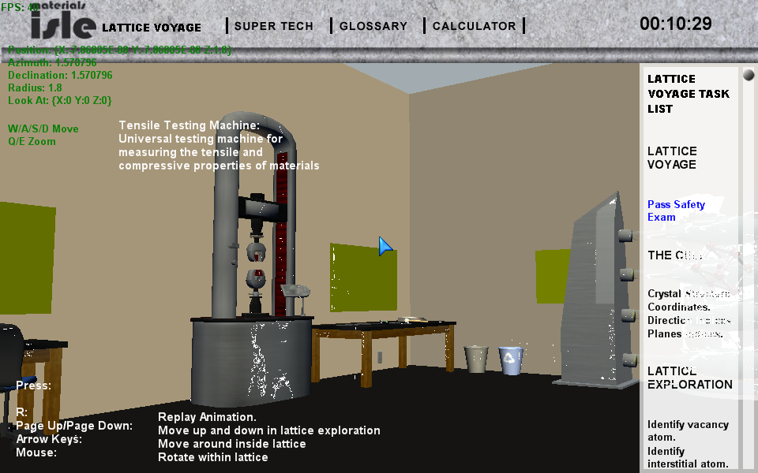
Once the user finishes looking about the simulated laboratory facility, then next step is to return to the Teleporter and select it. This initiates an animation simulating “flying through the lattice”, which is difficult to reproduce in this written document, but we present a screen capture during the flight below.
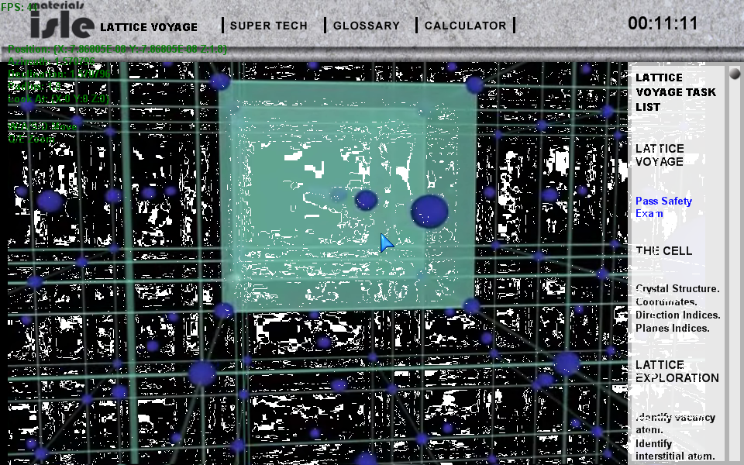
The next step in the laboratory experience, asks the student to identify features of the molecular structure.
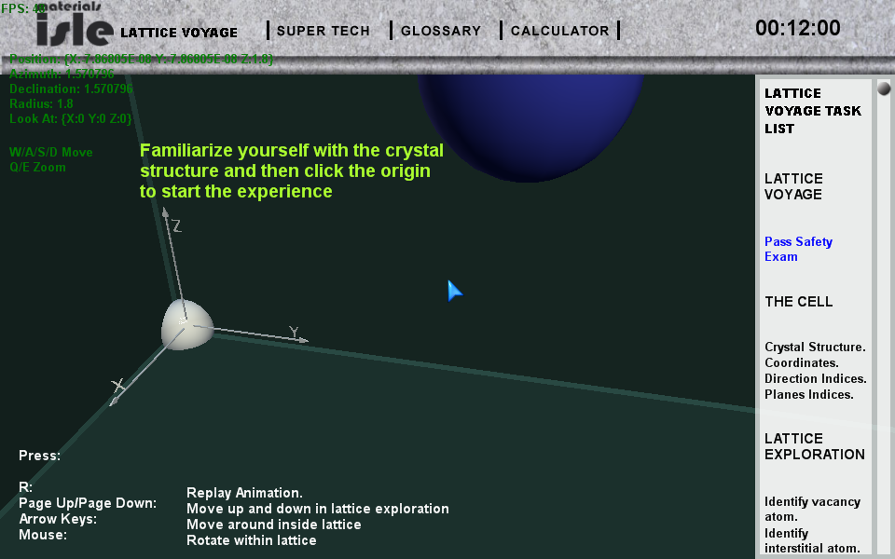
The student is free to use their mouse to move around in this scene to identify features and hopefully follow the instructions to click on the original once they hav identified it.
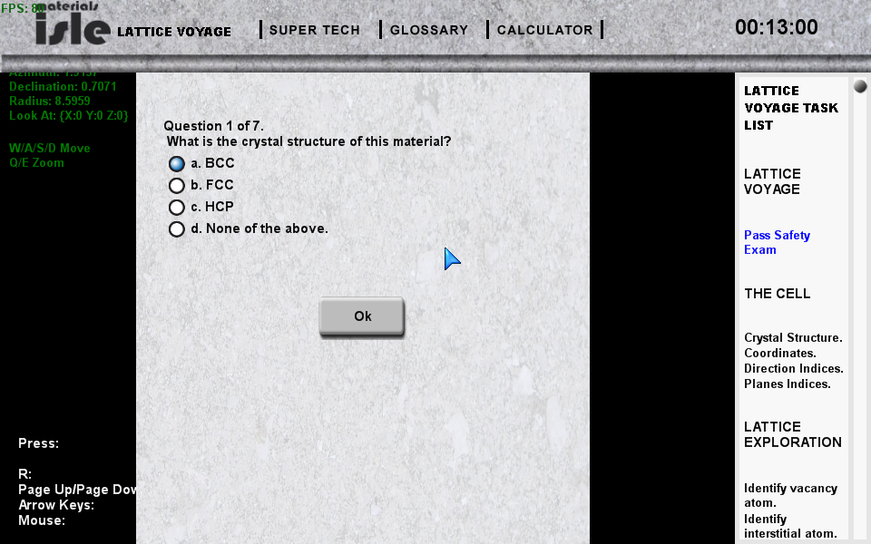
The next feature to identify the coodinates of the “pulsating” atom
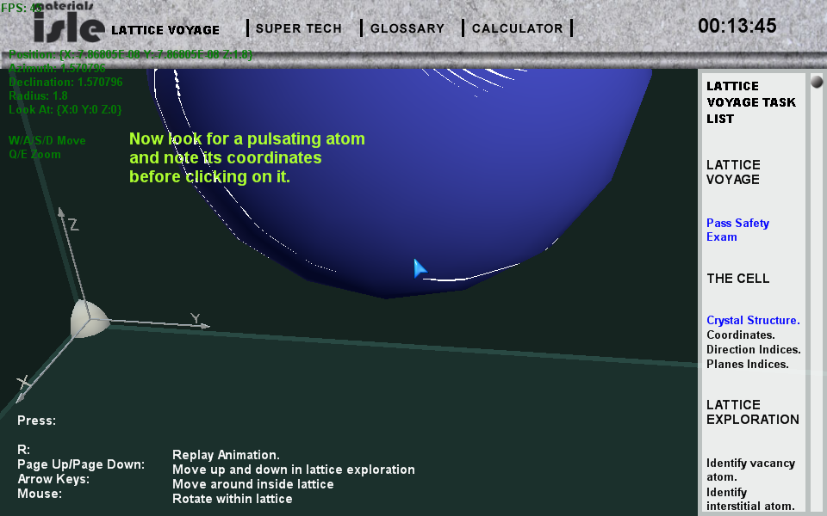

Followed by a recorded quiz question:
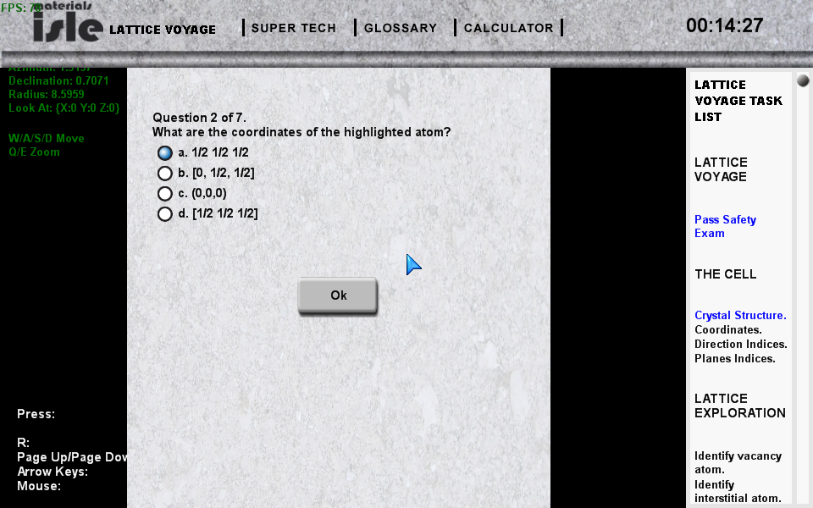

This laboratory finishes with asking the student to identify 3 structures within the lattice. There are the Interstitial Atom, the Vacancy and the Substitution Atom.
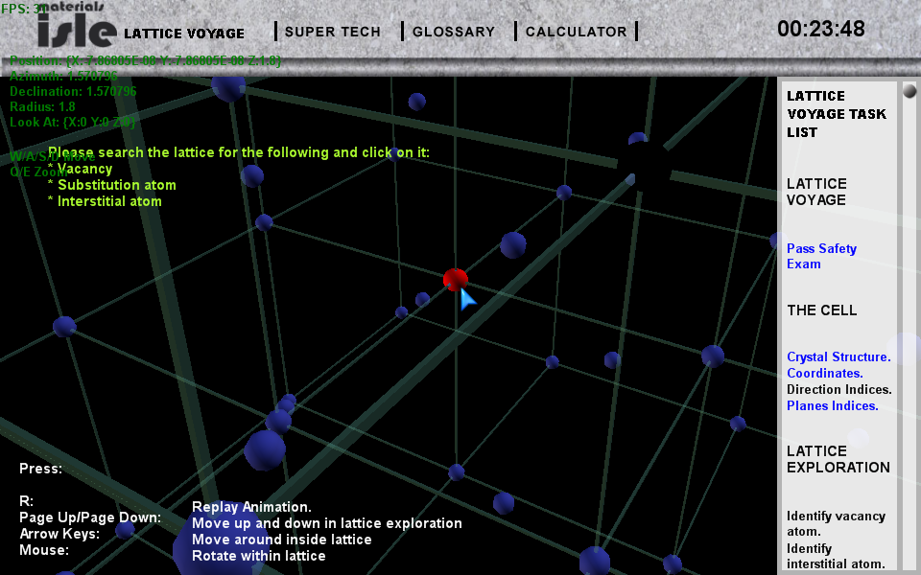
Once the student explores the lattice and clicks on the feature, they must identify it.
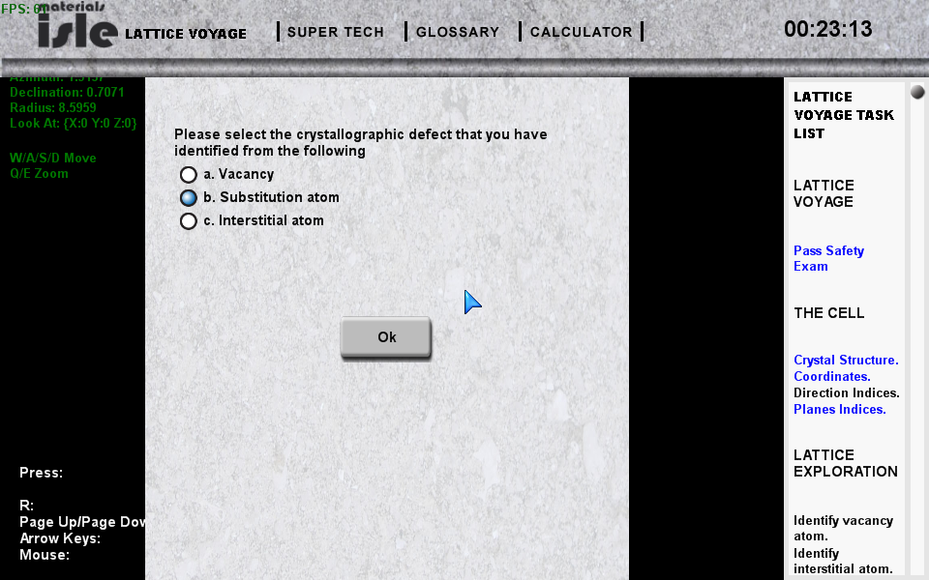

Once the student successfully searches for all three features and identifies them, they complete the lab.

